
Final Report
Of
Student skill and Internship Management System
Group No : 09

Registration Number | Index No | Name
ASP/2024/006 | 6470 | D.R.C.D.J. Bandara
ASP/2024/101 | 6530 | T.K.H. Jayawardhana
ASB/2024/023 | 6356 | M.R.N.H. Gunaratne
Course: COM 1302 Database Management System
Academic Year: 2023/2024

Department of Computing
Faculty of Applied Sciences
Rajarata University of Sri Lanka
Contents

- Case Study ........................................................................................................................ 1
  - Introduction
  - Problem Statement
  - Proposed Solution
  - Objectives
  - Conclusion

2. Database Requirements Analysis ...................................................................................... 2
3. ER / EER Diagram ............................................................................................................. 3
4. Relational mapping ............................................................................................................ 4
5. Normalization .................................................................................................................... 12
6. Database Implementation .................................................................................................. 13
7. SQL Queries and Results .................................................................................................. 14
8. Testing and Validation ...................................................................................................... 14
9. Conclusion and Future Improvements .............................................................................. 14

- Case Study
1.1 Introduction
Educational institutions need an effective system to manage student information, courses, departments, and students’ skills. Managing these details manually can cause data duplication, errors, and difficulties in retrieving information. Therefore, a Student & Skill Management System is proposed to store and manage student-related information in a centralized database.
1.2 Problem Statement
In a traditional student management process, student details, course enrollments, skill levels, and training program information may be stored in separate files or documents. This can lead to data redundancy, inconsistent information, and difficulties in updating and maintaining records. It may also be difficult to identify students’ skills and monitor their participation in different courses and training programs.
1.3 Proposed Solution
The proposed Student & Skill Management System uses a relational database to organize and manage information efficiently. The database consists of eleven main entities: Student, Department, Course, Enrollment, Skill, Skill_Category, Student_Skill, Skill_Level, Instructor, Training_Program, and Certificate.
Each entity stores specific information and is connected to related entities using primary keys and foreign keys. For example, a department can have many students and courses, while students can enroll in multiple courses through the Enrollment entity. Similarly, the Student_Skill entity records the skills acquired by students and their skill levels.
1.4 Objectives
The main objectives of this system are to reduce data redundancy, maintain accurate student records, manage course enrollments, record students’ skills and skill levels, and organize instructor and training program information. The system also aims to improve data consistency and make information retrieval easier.
1.5 Conclusion
The Student & Skill Management System provides a structured approach to managing student and skill-related information. By using a relational database and normalization techniques, the system can reduce unnecessary data duplication, improve data integrity, and support efficient information management within an educational institution.

- Database Requirements Analysis

- ER / EER Diagram

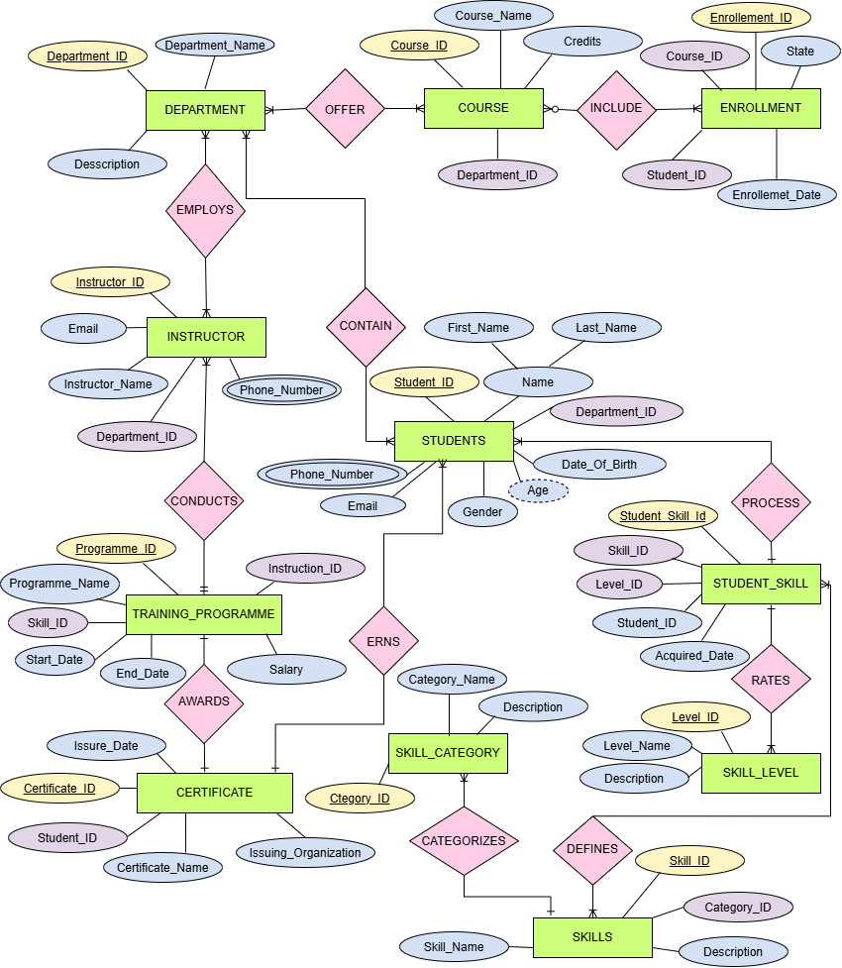
- Relational mapping

- Normalization
- Database Implementation

- SQL Queries and Results

- Testing and Validation

- Conclusion and Future Improvements

